#include<iostream>
#include<vector>

void swap(int *xp, int *yp)
{
int temp = *xp;
*xp = *yp;
*yp = temp;
}

void selectionSort(int arr[],int n)
{
int i,j,min_idx;

for(i = 0; i < n-1; i++)
{
min_idx = i;
for(j = i +1; j < n; j++)
if(arr[j] < arr[min_idx])
min_idx = j;

swap(&arr[min_idx], &arr[i]);
}
}

void printArray(int arr[], int size)
{
int i;
for(i = 0; i < size; i++)
std::cout<< arr[i] << " ";
std::cout<<std::endl;
}

int main(int argc, char* argv[])
{
int arr[] = {64,25,12,22,11};
int n = sizeof(arr)/sizeof(arr[0]);

selectionSort(arr,n);
std::cout<<"Sorted Array : \n";
printArray(arr,n);

return 0;
}

Output:
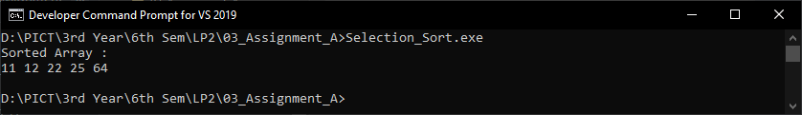

#pragma once
#include<iostream>
#include<vector>
using namespace std;

class SpaningTree
{
int v,e,w;
int **adjMatrix;
int * visited;
public :
SpaningTree(int v,int e);
void addEdge(int start,int e,int weight);
void minimumTree();
void printAdjMatrix();
};

SpaningTree::SpaningTree(int v,int e)
{
this->v = v;
this->e = e;
adjMatrix = new int*[v];
visited = new int[v];
for(int row = 0 ; row < v; row++)
{
visited[row] = 0;
adjMatrix[row] = new int[v];
for(int column = 0;column < v; column++)
{
adjMatrix[row][column] = 999;
}
}
}

void SpaningTree::addEdge(int start,int e,int weight)
{
adjMatrix[start][e] = weight;
adjMatrix[e][start] = weight;
}

void SpaningTree::printAdjMatrix(){
for(int row = 0 ; row < v; row++){
for(int column = 0;column < v; column++)
{ cout<<adjMatrix[row][column]<<"\t"; }
cout<<endl;
}}

void SpaningTree::minimumTree()
{
int p=0,q=0,total=0,min;
visited[0] = 1;
for(int count=0;count<(v-1);count++)
{
min=999;
for(int i=0;i<v;i++)
{
if(visited[i]==1)
{
for(int j=0;j<v;j++)
{
if(visited[j]!=1)
{
if(min > adjMatrix[i][j])
{
min=adjMatrix[i][j];
p=i;
q=j;}}}}}
visited[p]=1;
visited[q]=1;
total=total+min;
cout<<"Minimum cost connection is "<<(p)<<" -> "<<(q)<<" with charge : "<<min<< endl;
}
cout<<"The minimum total cost of connections of all branches is: "<<total<<endl;
}

#include"header.h"
int main(void){
SpaningTree st = SpaningTree(5,7);
st.printAdjMatrix();
st.addEdge(0,1,200);
st.addEdge(0,3,600);
st.addEdge(1,2,300);
st.addEdge(1,4,500);
st.addEdge(2,4,700);
st.addEdge(3,4,900);
cout<<endl<<endl;
st.printAdjMatrix();
st.minimumTree();}
